# Title Information

Ishika Patel

Plate Tectonics Lab

July 11, 2020

N/A

Table of Contents

Title Information 1

Data and Observations / Calculations 2

Exercise 1: Modeling Plate Tectonics 2

Photo Requirement: Exercise 1, Step 5 2

Data Table 1: Tectonic Plate Modeling 2

Exercise 2: Examining Tectonic Plates on a Digital Map 4

Photo Requirement: Exercise 2, Step 4 Completion 4

Data Table 2: Divergent Boundaries 4

Data Table 3: Convergent Boundaries 5

Data Table 4: Transform Boundaries 6

Lab Question Answers 7

Exercise 1 Questions 7

Exercise 2 Questions 7

Conclusion 9

References 9

# Data and Observations / Calculations

## Exercise 1: Modeling Plate Tectonics

### Photo Requirement: Exercise 1, Step 5

### Data Table 1: Tectonic Plate Modeling

|  |  |  |
| --- | --- | --- |
| **Plate Boundary** | **Photo** | **Description** |
| **Divergent** |  | This simulated plate boundary tore the clay apart. The Sides of the tear were rough and uneven. The edges are thinner than the ¼ inch simulated plate. The divergent plate boundary is simulated with the transparency paper being pulled an apart. Items such as oceans and trenches form through this process. |
| **Convergent** |  | There are creases along the dough. As one of the plates subducts the other, the dough was lifted above the flat ground. The convergent plates were simulated by bringing the transparency paper closer together. Convergent plate boundaries re prone of volcanos and earthquakes. |
| **Transform** |  | The dough demonstrated an uneven stretch along the transparency paper intersection. This simulation did not have the clay breaking completely, in did create uneven bumps (peaks and troughs). |

## Exercise 2: Examining Tectonic Plates on a Digital Map

### Photo Requirement: Exercise 2, Step 4 Completion

### Data Table 2: Divergent Boundaries

|  |  |  |
| --- | --- | --- |
| **Photograph** | **Location** | **Description** |
|  | Between the Eurasian Plate and the North American Plate. Notable location is right through Ireland. | This is a divergent plate boundary with oceanic meeting. Here the mid-Atlantic ridge is created by the slow pulling apart of the plates. In Iceland, one can directly observe the impact of this divergent plate boundary. (Nat Geo, 2013) |
|  | This is the divergent boundary between the Arabian plate and the African Plate. Here lies the Aden Ridge. | The immediate location of this ridge is in the Gulf of Aden. The most immediate boundaries are the African and Arabian Plate, but another plate involved is the Somalian plate. One distinguishing feature of this ridge rea is the triple junction it is in between these three places. Rifts are generally deep and narrow. (Nat Geo, 2013) |

### Data Table 3: Convergent Boundaries

|  |  |  |
| --- | --- | --- |
| **Step 16Photograph** | **Location** | **Description** |
|  | In the Pacific Ocean west of the Philippine Island (HOL Lab, 2020). This area is known as the Mariana Trench | Subduction occurs as the Pacific Plate undercuts the Philippines Plate. The trench formed is the world’s deepest Oceanic one. (Nat Geo, 2013) |
|  | This is the convergent boundary between the Indian Plate and the Eurasian Plate. | The biggest feature of this area is the Himalayan Mountain Stretch. The Indian Boundary is moving northward. This boundary region creates what is known as a “fold”. (Nat Geo, 2013) |

### Data Table 4: Transform Boundaries

|  |  |  |
| --- | --- | --- |
| **Photograph** | **Location** | **Description** |
|  | the active transform boundary is between the North American and Pacific plate. This is where the San Andreas fault is located | There is a small body of water between the plates which is a funny geologic addition. This fault is whereby the North American plate moves downwards to its relative direction and the Pacific plate moves upwards. (Nat Geo, 2013) |
|  | The Owens fracture zone is a transform boundary between the Arabian Plate and the Indian Plate | A major characteristic of this transform boundary is the frequency of earthquakes as the Indian Plate rubs against the Arabian Plate. (Nat Geo, 2013) |

# Lab Question Answers

## Exercise 1 Questions

1. **What type of convergent plate movement was simulated in the procedures, ocean plate or continental plate? Explain your answer.**

In the simulation of the convergent plate boundary, the transparency papers were brought closer together. Continental plate movement was simulated in the procedures because folding and faulting of the crust occurred as opposed to subduction (HOL Lab, 2020). I looked into the 2015 Nepal Earthquake where an earthquake occurred between the Eurasian continental plate and the Indian continental plate, and at the boundary was a convergent boundary.

1. **Which type of plate boundary produces new material? How does this process occur?**

A divergent plate boundary produces new material. As the plates spread, the lithosphere fractures and if this process occurs under water, magma shoots up to form new rock; therefore, new material is produced. (HOL Lab, 2020).

## Exercise 2 Questions

1. **Describe the characteristics of divergent plate boundaries that occur on land.**

Divergent plate boundaries are notorious for their ability to create new rock when the lithosphere stretches and if magma form oceanic floors pushes up (HOL Lab, 2020). Rifts are the main product of divergent boundaries where “streams and rivers flow into the sinking valleys within the rifts’ (HOL Labs, 2020). These rifts can grow as big as to form oceans and seas!

1. **What type of boundary occurs between the African and Arabian tectonic plates? Support your answer by referencing features on your digital relief map.**

The most notable feature of the boundary between the African and Arabian tectonic plates is the Death Sea Transform, which is a transform boundary in the Red Sea Area (Nat Geo, 2013). The plates here are diverging and have created the Dead Sea and area of water within desert climate.

1. **Describe the characteristics of convergent plate boundaries that occur between two continental plates.**

Convergent plate boundaries between two continental plates create mountains and folds (HOL Lab, 2020). The two plates that create a convergent boundary are the Eurasian Plate and the Indian Plate. The feature that tells me with surety that this boundary is convergent are the Himalayan Mountains. Not to mention, in my research for the discussions I looked into this plate boundary and the 2015 Nepal Earthquake which continue to support this convergent boundary. At convergent boundaries earthquakes are commonplace (HOL Lab, 2020).

1. **Use your digital relief map to locate evidence of the convergence between an ocean plate and a continental plate. Name the two plates that create this boundary and list the map features that lead to your conclusion.**

The Japan Trench is evidence of a convergent boundary between an ocean plate and a continental plate. This Trench, primary evidence of the subduction in convergent plates occurring, is between the oceanic Pacific Plate and the continental North American Plate. (Grossi et. Al, 2018)

Image also from Grossi et. Al, 2018

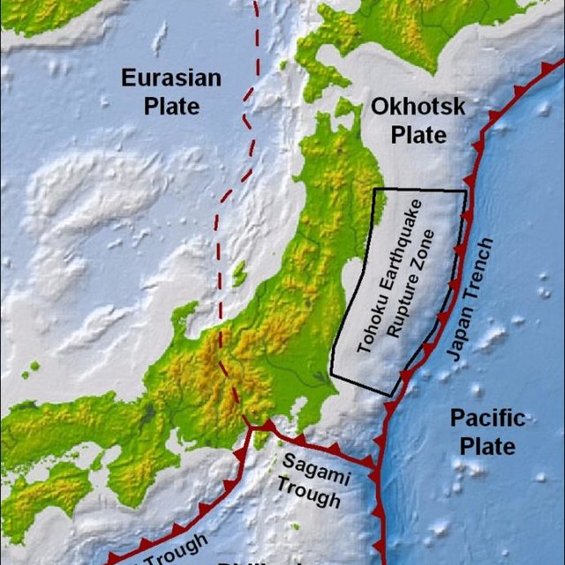

# Conclusion

This lab was extremely informative of the different plate tectonic boundaries. To sum up the first exercise, I looked into how the different types of boundaries: divergent, convergent and transform create different textures and shapes in Earth’s crust. Divergent Boundaries are the type of boundaries which have the ability to create new rock formation. Convergent Boundaries create Mountains and Volcanoes. If there is subduction occurring then a volcano can form (HOL Lab, 2020). Transform boundaries are super unique in that the plates are rubbing horizontally.

In Exercise 2, I went in depth into looking at the different types of plate boundaries and how they have manifested. I learned so much about the different characteristics of the boundaries such as forming seas and mountains and having earthquakes. Exercise 2 was useful in looking at how the plates are moving continuously. This made me thoroughly consider: How will Earth look different in the next thousand years?

This lab was a heavy load of research to truly understand the tectonic plates and where they lay. I was also adding to my knowledge from Module 1 of the different parts of Earth from core to mantle to crust.

# References

Grossi et. al., P. (2018, August 01). Japan's tectonic setting. Retrieved July 11, 2020, from <https://www.researchgate.net/figure/Japans-tectonic-setting-illustrating-the-three-subduction-zones-Nankai-Trough-Sagami_fig1_309173507>

Nat Geo. (2013, March 05). Plate Tectonics. Retrieved July 11, 2020, from <https://www.nationalgeographic.org/topics/resource-library-plate-tectonics/?q=&page=1&per_page=25>

Physical Science Department. (2020, Summer). GEY111 HOL lab manual.  Colorado: CCCOnline.  Retrieved from class website at:

<https://ccco.desire2learn.com/d2l/le/content/2768021/viewContent/29148201/View>

Physical Science Department. (2020, Summer). GEY111 Lab Report Assistant.  Colorado: CCCOnline.  Retrieved from class website at:

<https://ccco.desire2learn.com/d2l/le/content/2768021/viewContent/29148190/View>